C E R TI F I C A T E
It is certified that the instructions and responsibilities have been apprised to the Elected President, Vice President, Vice President, General Secretary and Classroom Representatives (CR) of this school and being followed under mentioned instructions in true letter and spirit.
Sr.# | Activity | Pictorial Evidence
1 | Ensured affixing banners/panaflaxes incorporated with responsibilities of student Council at the prominent places of the school | 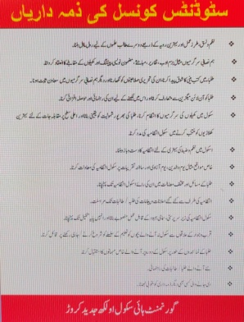
2 | The Elected Member of Students Council being attended the school in neat and clean dress code/uniform with Sash. | 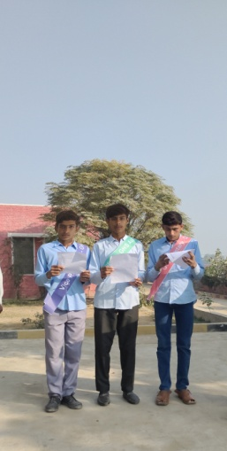
3 | The Elected Members of Students Council and CRs have become helpful to maintain the school/Classroom discipline. | 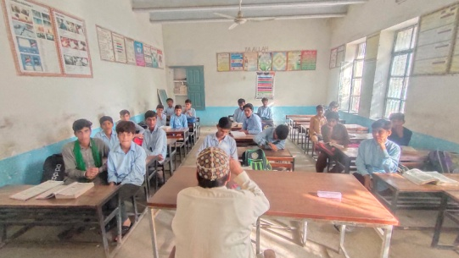
4 | The Elected members of students council are well versed with their responsibilities and are able to explain their obligations before the higher authorities all time | 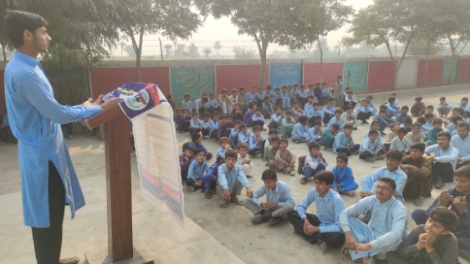
5 | The cleanliness of members of student council and CRs are exemplary as Role Model | 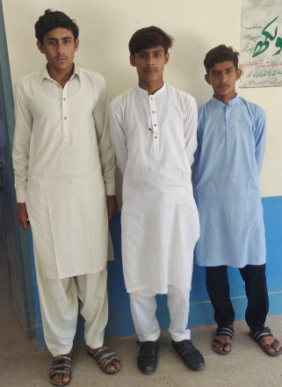
6 | The Members of student council are showing best performance in studies in the classroom and their behavior is like a gentleman in and outside the school | 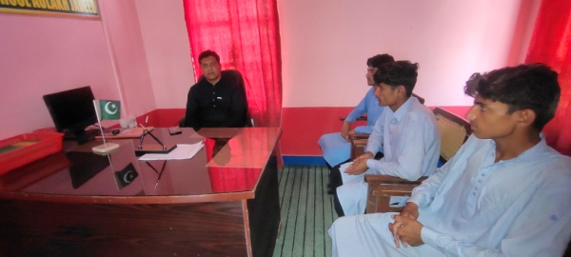

Signature of Elected Members
1-President ____________________
2-V.President.___________________
3-G.Secretary _____________________
4-C.R _______________________________

